MinXSS Commissioning Plan

**Table of Contents**

Commissioning Test Objectives

Pass / Safety Priorities

Personnel Roles and Responsibilities

Roles

Script Leads

Display Monitoring

Pre-Pass Procedure

During Pass

If Issues Communicating During Pass

Operator Actions If Telemetry Point Out of Limits

Test 1: Do Aliveness Test

Test 1.5: Disable Auto-Deploy

Test 2: Configure and verify ADCS fine point

Test 3: Do instrument aliveness (in safe mode)

Test 4: Go to Science Mode

Test 5: Adjust X123 thresholds

Post-Pass Procedure

# Discussion on order of commissioning

James and Robert talking through the order we think things should go. Robert also suggests wrapping all of this up in one wrapper script so you can progress to the next phase if you finish one phase really quick (e.g., aliveness) (this is what MMS did).

1. Aliveness
2. Set time (also works as a command uplink verification)
3. Playback deployment data (ADCS rolls over in just 3 days)
4. Instrument aliveness (in safe mode)
5. Load ephemeris
6. Go to science (check out fine point mode)
7. Adjust X123 thresholds

# Commissioning Test Objectives

Each test sequence is defined for 1 pass per test. Data dumps are also anticipated during some passes, so goal is run one commissioning test sequence per day and be in normal science operations in about a week after deployment from ISS.

|  |  |  |
| --- | --- | --- |
| Test Sequence | Objective | ~Time to complete script with no catches (should be < 5 min) |
| 1 | Do aliveness test | 3 minutes |
| 2 | Configure and verify ADCS fine point | 3 minutes |
| 3 | Do instrument aliveness test in safe mode |  |
| 4 | Go to science mode |  |
| 5 | Adjust X123 threshold | Multiple days including analysis |

# Pass / Safety Priorities

1. Battery voltage ≥ 7.0 V
2. Sun point status
3. Bus subsystems healthy + commands functional
4. Instruments healthy

# Personnel Roles and Responsibilities

## Roles

* MOM: Mission Operations Manager
  + Tom Woods
  + Rick Kohnert – Deputy MOM
* Commissioning Operators
  + James Mason – lead for comm, power, ADCS
  + Colden Rouleau – lead for playback data
  + Chris Moore – lead for instruments, Amir Caspi
* Radio Comm / Antenna / SatPC32
  + Scott Palo – lead James & Colden
* BCT XACT ADCS
  + Matt Baumgart – lead & BCT team remotely (e.g. Room 299)
* Planning (playback) Software
  + Colden Rouleau – development & test
  + Chris & James for weekly / daily planning
* Post-pass Data Processing
  + James Mason – lead Chris & Colden
* SolarSoft IDL Package
  + Amir Caspi

## Script Leads

* James Mason
  + commission_aliveness_phoenix
  + commission_deploy_arrays
  + commission_aliveness_safe
  + commission_set_spacecraft_time
  + commission_set_ephemeris
  + commission_test_fine_point
  + commission_science_mode
* Colden Rouleau
  + playback_all_data_DATE_TIME
* Chris Moore
  + commission_instrument_aliveness
  + commission_x123_thresholds

## Display Monitoring

* MOM Oversight (Tom)
* Station 1 (OPS-1 Dell 27”)
  + ISIS command & telemetry
  + Script Operator (James)
  + Critical Panel Monitor (Rick)
* Station 2 (Rocket6 HP 21”)
  + SatPC32 & ISIS science telemetry
  + Antenna Operator (Colden)
  + Instrument Monitor (Chris)
* Station 3 (OPS-2 Dell 27”)
  + ISIS telemetry
  + ADCS Monitor (BCT person)
* Station 4 (iMac 27”)
  + Mac Data Processing
  + Real Time Plots Monitor (Chris)

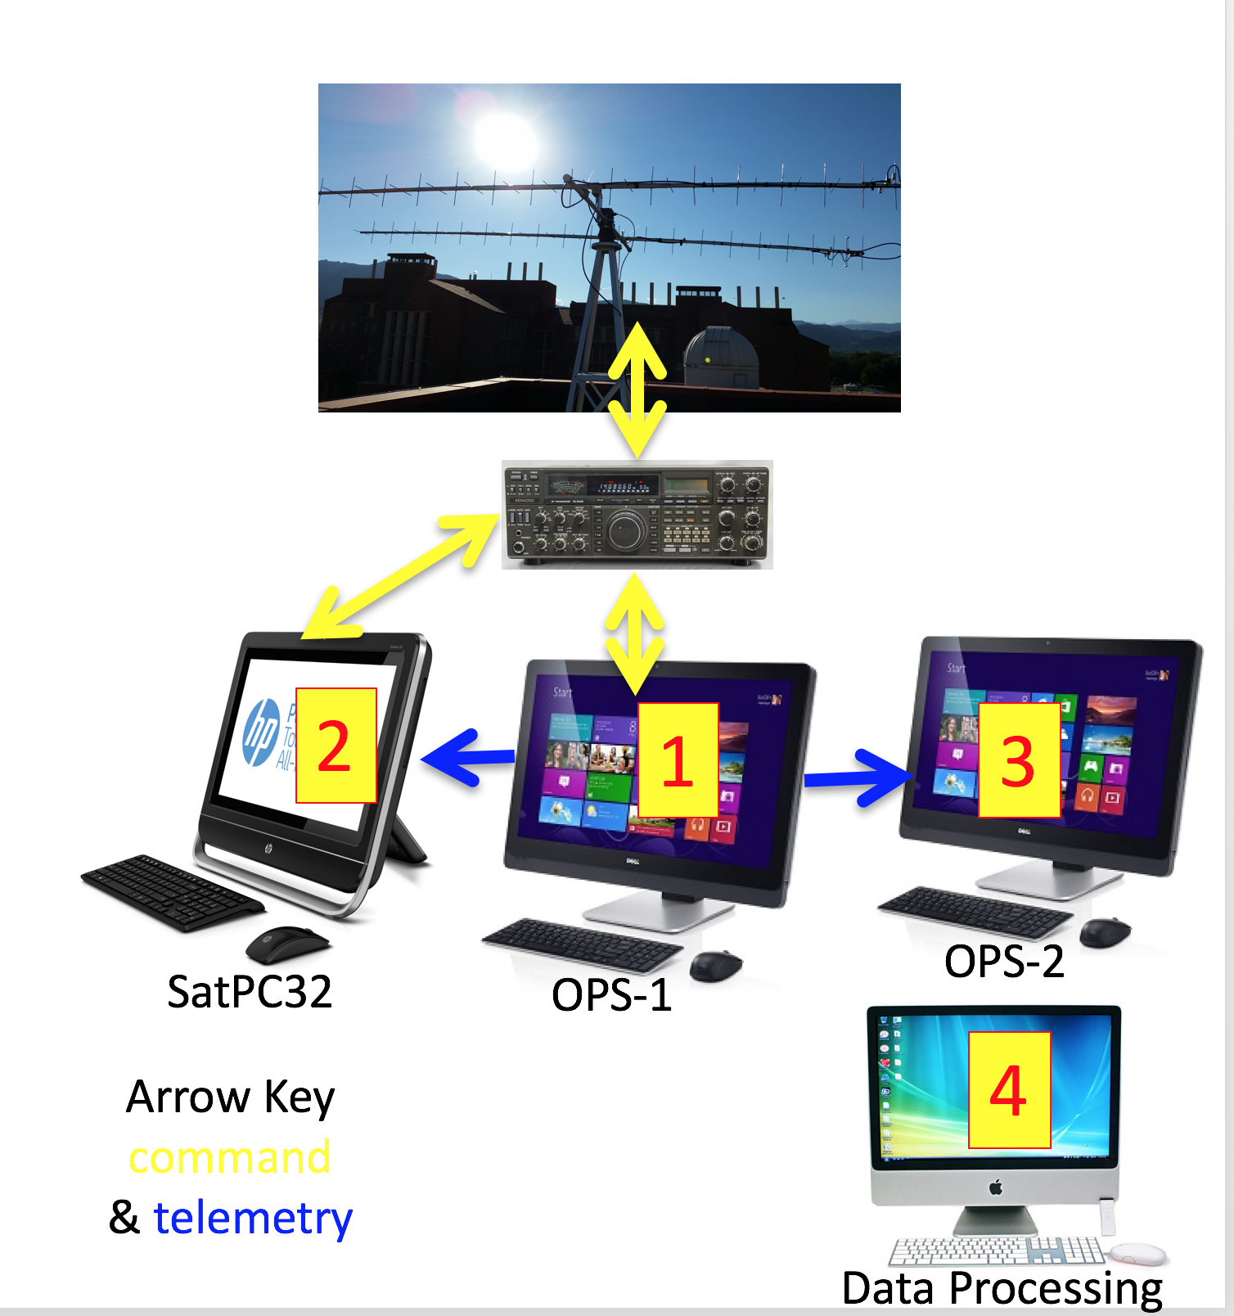

# Pre-Pass Procedure

1. Make sure that MinXSS FM-2 is not running, and that the roof antenna is connected to the radio
2. Print a blank copy of [8090-002 MinXSS Pass Sheet template](https://drive.google.com/open?id=1sXt8pgKD0enD6oNBARai5x0Ux4fv36d-SyW16cHusVE) or be prepared to fill it out electronically and print it after the pass
3. Ensure SatPC32 is running on Rocket6 computer (HP 21”)
   1. Ensure that rotor and frequency control are enabled in the upper left (should read R**+** and C**+**)
   2. Ensure SatPC32 is configured to point to and use MinXSS’s frequency (437.345 MHz) (see bottom right, should be configured for “A”)
4. Review all scripts that need to be run this pass
5. Prepare ISIS playback script OR be ready to use playback_all_data_last_24_hours.prc, which plays back the last 24 hours of data in 5 minutes (10-min cadence for HK and SCI, 20 min for ADCS). Ensure that playback script is appropriate for the pass type (e.g., when commissioning ADCS, we’ll want an ADCS-specific pass ready, and when doing pre-science commissioning we won’t want SCI data)
   1. If something's wrong from previous data, prepare a custom script to downlink data to address that. This script should be stored in post-pass.
   2. If nothing was wrong in previous data, and if this pass is ***not***the longest pass of the day, prepare a custom script to downlink specialized data with higher cadence (e.g., more ADCS if we're not yet in science mode). This script should be stored in post-pass.
   3. If nothing was wrong in previous data, and if this ***is*** the longest pass of the day, run playback_all_data_last_24_hours.prc. This script should be stored in post-pass even though it’s identical every time so that we have a consistent historical record of .prc files run.
6. Launch ISIS on OPS-1 computer (WinD2791 Dell 27”)
   1. Ensure relevant Display Pages opened: HK, SCI, playback, command buttons, param dump, and command status (the last is opened from View menu). Also ensure the critical telemetry window is open on the second monitor.
      1. This can all be done by doing “load_dc” if it fails to do it on its own when opening
7. Open powerpoint on the OPS-1 computer. It will prompt you for a template. Go to Personal, and select the MinXSS template. Fill out the title slide and then you can minimize powerpoint.
8. Launch IDL on DataProcessing computer (iMac MacL68) and start IDL real time plotting routines
   1. minxss_trunk/real_time/ and then select the code as appropriate: e.g., minxss_real_time_socket_read_wrapper_adcs or minxss_real_time_socket_read_wrapper_sci
9. Ensure we understand any coordination plans we’ve made with CADRE, and either start the pass late or end it early if necessary
10. Get screenshare and communications set up for BCT.
    1. Turn on join.me for screenshare on OPS-2. Help BCT get projector running with the shared screen in LSTB 299 auditorium.
    2. Get the wireless phone from the Kepler MOC and establish phone call between it and the phone in the 299 auditorium. The MOC phone number is 303-492-4211.

# 

# 

# During Pass

1. Run *hello_minxss.prc* script to establish communications with MinXSS (see here if issues communicating during pass)
2. Once telemetry is displayed in ISIS, resize the windows slightly so that the spacing fixes itself
3. Take a screenshot of the HK window by pressing “windows-key + print screen”, which will save a screenshot to the directory OPS\Pictures\Screenshots.
4. Verify the critical telemetry is in-bounds (if not, see “MinXSS Recovery Instructions”). Note that Test 1 *will* proceed if the spacecraft is in Phoenix mode.
5. Proceed to the Test instructions as appropriate: Test 1, Test 2, Test 3, Test 4, Test 5

**Note**: Do notx-out of ISIS windows to close them because ISIS will crash. Just minimize windows if needed.

# If Issues Communicating During Pass

Follow the steps below if you do not receive autonomous beacons or response from commanded *issue_hk_packet*, which is what the *hello_minxss.prc* script does and should be run at the beginning of every pass

**Note 1**: Communication issues are especially likely during the first pass

**Note 2**: In safe mode, the spacecraft won’t be trying to keep the antenna pointed optimally[1], but default roll rate is ~0.2º/sec[2] (read, slow), so we’ll be stuck in a gain null or not for a long time

**Note 3:** The spacecraft will not be on (and therefore the antenna will not deploy) for the first 30 minutes after it leaves the ISS, so if we get a pass in that window we should expect comms not to work

1. Make sure the Kenwood radio volume is up so beacons can be heard

2. Tune ground antenna pointing

* 1. First try switching SatPC to use the CADRE TLE
     1. In the lower right of SatPC, double click “B”, which is the second loaded satellite, and should have been set up for CADRE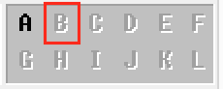
  2. Have a person dedicated to manual control of the Elevation-Azimuth Dual Controller G-5500 box 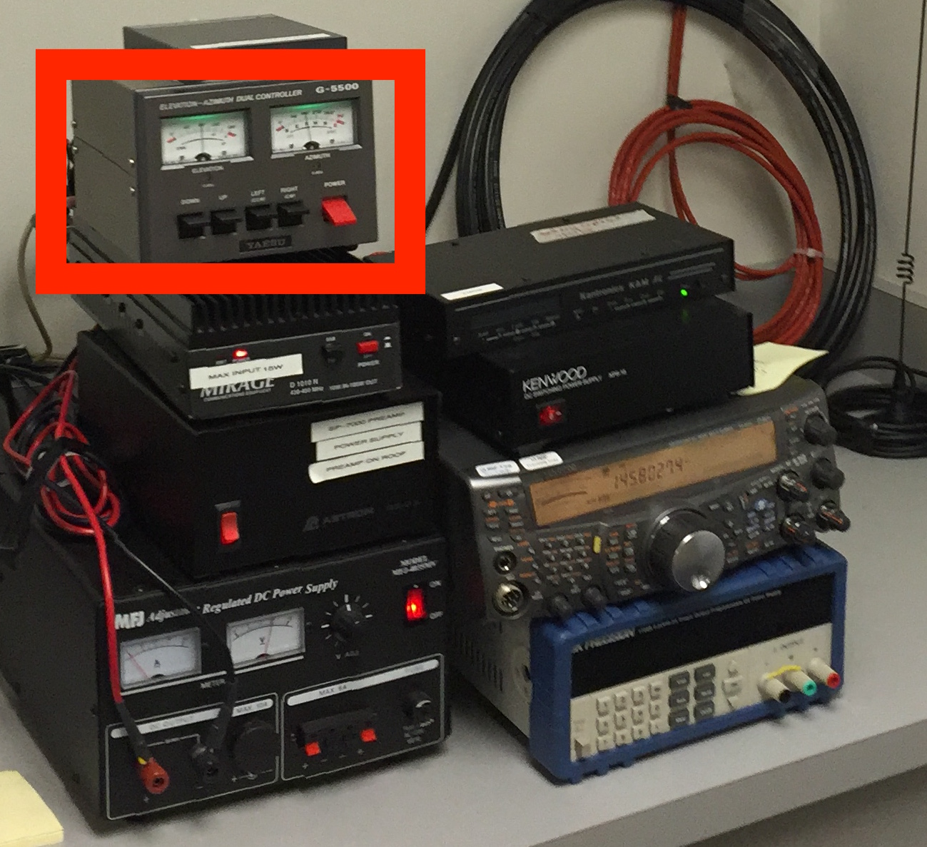
  3. Disable SatPC automatic control of rotors
     1. Upper left of SatPC, change R+ to R- 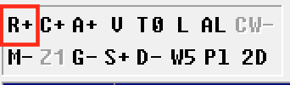
  4. While ISIS continues to run the *hello_minxss.prc* script, sweep slowly in elevation and azimuth
  5. If a beacon is heard from the Kenwood radio, note the discrepancy from what SatPC expects at that moment
  6. Continue manual control of the ground antenna pointing throughout the pass, with SatPC as a guide
  7. After the pass, note the discrepancy and adjust SatPC accordingly (TLE improvement, antenna pointing offsets)

3. Tune radio frequency

* 1. Have a person dedicated to manual control of the Kenwood radio
  2. Disable SatPC automatic radio tuning
     1. Upper left of SatPC, change C+ to C- (CAT control) 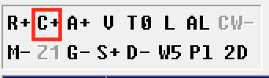
  3. Tune radio frequency slowly, noting the below
     1. The best frequency during ground testing was 437.345 MHz
     2. MinXSS radio has bandwidth of 0.15 MHz
     3. CADRE is using 437.485 MHz with the same radio
     4. Max Doppler shift is 0.003432 MHz
  4. If a beacon is heard from the Kenwood radio, note the discrepancy from what SatPC expects at that moment (**Note:** If the Kenwood makes sound but we don’t get telemetry data, then it’s from CADRE! Don’t tune the frequency/location to CADRE!)
  5. Continue manual control of the frequency throughout the pass, with SatPC as a guide (to compensate for Doppler)
  6. Consider turning off SatPC Doppler correction (CSSWE had to at first)

4. Reset the flight radio by command: *power_cycle_comm*

* 1. Radio is known to lock up and give intermittent telemetry out if the *comm_amp_level* command is sent, cause unknown, so space environment could potentially cause this lock up. **Note**: the lockup also causes the radio temperature to rise dangerously, reset fixes it

5. Plug Scott Palo’s spectrum analyzer in the pipe between the antenna and the radio

* 1. Make sure Scott Palo or someone who knows how to use it is present to see if any signal is coming through

6. If all else fails, consider rebooting the CDH with command: *trigger_watchdog_reset*

1. Only take this drastic action if we’re sufficiently separated from CADRE

7. Finally, keep trying ?? days for the fishing line to degrade (in this case we’re assuming the antenna did not deploy)

# 

# 

# Operator Actions If Telemetry Point Out of Limits

These are actions for the operator to take in response to any individual telemetry point being out of limits. There aren’t a whole lot of commands that can influence things, so the telemetry points have been grouped according to common operator responses.

|  |  |  |  |
| --- | --- | --- | --- |
|  | HK Monitor | Safe Range | Action if Out of Range |
| Mode Issues | CDH Mode | Science (Safe) | Phoenix: Wait until battery is charged or force to Safe mode  Safe: Wait until battery is charged or configure X123 to power cycle off during eclipse  Scripts: commission_aliveness_phoenix, comission_aliveness_safe |
| XACT Mode | Fine Point (Sun Point) | ADCS Off: Force to Safe mode or turn on ADCS  Sun Point / Safe: Wait until Science mode or force to Fine Point mode  Scripts: commission_set_ephemeris, commission_science_mode, commission_test_fine_point |
| Power Issues | Battery Voltage | 7.0 - 8.4 V | Shed power: X123, SPS |
| Discharge Current | 0-2000 mA | Low Current: Identify which subsystem is off and turn it on (or change Mode)  High Current: Identify which subsystem is cause of high current and power cycle it. |
| Charge Current | 0-2000 mA |
| 3.5 V Current | 200-400 mA |
| 5.0 V Current | 0-1500 mA |
| Temp Issues | Battery Temperature | 2-8 C | Heater Issue: Disable / Enable battery heater and reset its set point temperature  Too Hot: wait for orbit change or power cycle X123 during eclipse |
| X123 Det Temperature | 220-235 K | Set and Verify X123 detector temperature setting |
| X123 Bd Temperature | 10-40 C | Too Hot: power cycle X123 during eclipse |
| Radio Temperature | 10-40 C | Too Hot: power cycle COMM if L1-I radio is hung |
| Science & Pointing Issues | SPS Angle X | -1000 to 1000 | First verify that S/C is in the Sun.  Not on Sun: identify and fix ADCS pointing issue  (see Mode Issue scripts listed above)  X123 Counts high in eclipse: adjust THFA / THSL  Script: commission_x123_thresholds |
| SPS Angle Y | -1000 to 1000 |
| SPS Signal |  |
| XP Signal |  |
| Dark Diode Signal |  |
| X123 Slow Count |  |
| X123 Fast Count |  |

# 

# 

# Test 1: Do Aliveness Test

(1.1a) If in PHOENIX (i.e. you wknow it’s been <30 min since deployment) then

start commission_aliveness_phoenix

hello_minxss

route_hk_pkt Route 5 ; repeat until see command success

call cdh_tlm_check

call eps_tlm_check

call comm_tlm_check

set_spacecraft_time

route_hk_pkt Route 1

Also, see “MinXXS Recovery Instructions” under Mode Issues and Power Issues

(1.1b) Else if in SAFE then (Note: this is safe to run in phoenix)

start commission_aliveness_safe

hello_minxss

route_hk_pkt Route 3 ; repeat until see command success

set_spacecraft_time_now ; repeat until see command success

call cdh_tlm_check

call eps_tlm_check

call comm_tlm_check

call adcs_tlm_check

call sps_tlm_check

call adcs_aliveness

route_hk_pkt Route 5

(1.2) Optionally do playback of data if Battery Volt > 7.0 V (or Wait until next pass)

DO NOT RUN IF WITHIN LOS - 3 MINUTES

call playback_deployment_data(except science) ****NEEDS FIXING****

REPEAT TEST 1 UNTIL IN SAFE MODE WITH SUN POINT

Critical for First Pass

1. HK packets received - prepare to adjust radio frequency
2. ADCS Mode is in SUN_POINT and Sun Body X is ~ 1.0
3. SA 1-3 Power is > 7 W (if in sun)

# 

# 

# Test 1.5: Disable Auto-Deploy

1. Verify that the antenna and solar arrays are deployed
   1. Antenna is verified to be open by the fact that communication is working at all
   2. Solar arrays open can be verified by looking at the 3 solar panel powers (W) in the critical telemetry panel during an insolated period
2. Send the cancel_ant_deploy_retry command
3. Verify the command accept counter increments, if not, keep sending the command

# Test 2: Configure and verify ADCS fine point

(2.1) start commission_set_adcs_time ; repeat until success

(2.2) start commission_set_ephemeris

* adcs_InitPosVelUtcGreg Year Mon Day Hour Min Sec millisec PosX PosY PosZ VelX VelY VelZ
  + e.g., adcs_InitPosVelUtcGreg Year 15 Mon 3 Day 24 Hour 15 Min 28 Sec 0 millisec 0 PosX 7000 PosY 0 PosZ 0 VelX 0 VelY 0 VelZ 7.7
* adcs_SetAttitude Q_b_wrt_i_1 Q_b_wrt_i_2 Q_b_wrt_i_3 Q_b_wrt_i_4
  + e.g., adcs_SetAttitude Q_b_wrt_i_1 0 Q_b_wrt_i_2 0 Q_b_wrt_i_3 0 Q_b_wrt_i_4 1
* tlmwait MINXSSADCSAttitudeValid_Tlm_All == 1 or YES or VALID
* tlmwait MINXSSADCSRefsValid_Tlm_All == 1 or YES or VALID
* tlmwait MINXSSADCSTimeValid_Tlm_All == 1 or YES or VALID

(2.3) start commission_test_fine_point

* Is MinXSS on dayside of orbit? NO → (1.3)
* Is ADCS in Sun-Point mode and within 10 deg of Sun ? NO → (1.3)
  + Verify by checking ADCS packet 4(?) for present attitude error
  + Verify by plotting N seconds of SPS position data
* adcs_GotoFineSunPoint (parameters = enable, 6, 1, 2, 0)
* tlmwait fine_sun_point
* playback data later to analyze performance

(2.4) Optionally do playback of data if Battery Volt > 7.0 V (or Wait until next pass)

call playback_all_data_last_24_hours (except science)

REPEAT TEST 2 UNTIL SCRIPT SUCCESS

# Test 3: Do instrument aliveness (in science mode)

(3.1) Is MinXSS on dayside of orbit? NO → (1.3)

(3.2) Is ADCS in Sun-Point mode and within 10 deg of Sun ? NO → (1.3)

* Verify by checking ADCS packet 3 (Display Page → MinXSS_ADCS_3) for “Sun Point Angle Error” in bottom right (TODO: Update to point to “critical ADCS panel”
* Verify by plotting N seconds of SPS position data

(3.3) Is “SA/Battery V” > 7.5 V? NO → (1.3)

start commission_instrument_aliveness

route_hk_pkt Route 3 ; repeat until see command success

call sps_tlm_check

switch_power_x123 PowerDirection 1

call x123_tlm_check

switch_power_x123 PowerDirection 0

route_hk_pkt Route 5

(3.4) Optionally do playback of data if Battery Volt > 7.0 V (or Wait until next pass)

call playback_all_data_last_24_hours (except science)

REPEAT TEST 3 UNTIL IN FINE POINT

# Test 4: Go to Science Mode

(4.1) Is MinXSS on dayside of orbit? NO → (1.3)

(4.2) Is ADCS in fine reference mode and within 5 deg of Sun ? NO → (1.3)

* Verify by checking critical telemetry data window for “Sun Point Angle Error”
* Verify by plotting N seconds of SPS position data

(4.3) Is Battery Volt > 7.5 V? NO → (1.3)

start commission_science_mode

route_hk_pkt Route 3 ; repeat until see command success

set_mode_sci

call sps_tlm_check

call x123_tlm_check

route_hk_pkt Route 5

REPEAT TEST 4 UNTIL IN SCIENCE MODE

# 

# 

# Test 5: Adjust X123 thresholds

THIS TEST IS LIKELY TO BE A MANUAL THRESHOLD SELECTION RATHER THAN AUTOMATED. SPEAK TO SCIENTISTS TO DECIDE HOW TO PROCEED.

(5.1) Is MinXSS in eclipse? NO → (1.3)

(5.2) start commission_x123_thresholds

route_hk_pkt Route 3

loop until x123 normalized slow counts in hk < 10

Initial THSL = 1.0

THSL+= THSL + 0.1

loop until x123 normalized fast counts in hk < 10

Initial THFA = 16.0

THFA += 0.5

(5.3) Verify by analysis

REPEAT TEST 5 UNTIL COUNTS IN ECLIPSE ARE ≤ 10 cps

# Post-Pass Procedure

1. Fill out the pass sheet (by hand or electronically and then print it)
2. Move the screenshots from OPS\Pictures\Screenshots to the powerpoint slides that you set up in the Pre-Pass Procedure.
3. 3 hole punch these sheets and put them in the MinXSS Pass Binder
4. Close ISIS (File -> Exit)
5. Edit the filenames of all scripts run during the pass to end with _*yyyymmdd_Pass#_ran*, for example playback_all_data_last_24_hours_20160211_Pass3_ran.prc.
6. Copy everything in the ISIS run directory (03 ISIS\Rundirs\yyyy_doy_hh_mm_ss) that ISIS just generated is in the shared Dropbox folder on the hard drive (Dropbox/minxss_dropbox/isis_rundirs)
   1. Note: All passes in a day go into the same ISIS yyyy_doy_hh_mm_ss folder but a new .out file is generated each time ISIS opens or when it is commanded to rollover the telemetry file
   2. You can just copy the whole yyyy_doy_hh_mm_ss folder as long as you **make sure to replace all files**; **the dialogue box that asks you about this often appears behind all other windows**
7. On the DataProcessing computer (iMac MacL68), run *minxss_read_packets.pro* in IDL on the new telemetry file
8. Then run *minxss_make_level0b.pro* on the result of the previous step (a .sav file)
9. Then run *minxss_make_level0c.pro* on the result of the previous step (another .sav file)
10. Then run *minxss_plots_trends.pro, minxss_plots_power.pro* on the result of the previous step
11. If appropriate, run *minxss_plots_adcs.pro* as well
12. Colden: Run python scripts to populate/update the packet database (or email Colden if he’s not there)

1. In sun-point mode, XACT tries to keep the rates to 0 based on the IMU, but the IMU itself has a bias of about 0.2º/sec, which won’t be corrected
2. XACT can accept a command to increase this roll rate, but it can’t get any lower than this default